What are generative adversarial networks (GAN)?
Generative adversarial networks (GAN) are a type of artificial intelligence algorithm used in unsupervised machine learning and is a two-player neural network composed of a generator and a discriminator. The generator is tasked with producing synthetic data samples that are indistinguishable from real data samples, while the discriminator is tasked with differentiating between the synthetic and real data samples. The goal is for the generator to be able to produce data that is so realistic that the discriminator cannot tell the difference between synthetic and real data.

The following 11 types of GANs are used for computer vision:

1. Vanilla GANs
A vanilla GAN is composed of two neural networks: a generator and a discriminator. The generator is responsible for generating new data, and the discriminator is responsible for discriminating between generated data and real data.
The generator is initially trained to generate data that is indistinguishable from real data. Then, the discriminator is trained to discriminate between generated data and real data. The goal is for the generator to generate data that the discriminator cannot distinguish from real data.
The advantage of vanilla GANs is that they are relatively simple to implement and they perform well in a wide range of applications. The disadvantage of vanilla GANs is that they are relatively unstable and can easily fail to converge.
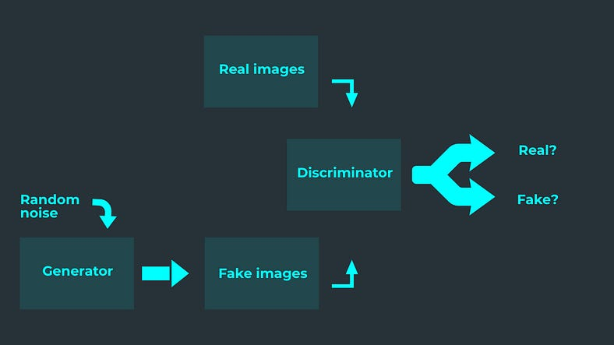

2. Cycle-GAN algorithm
A Cycle-GAN is a GAN in which the generator and discriminator are repeatedly trained in a cyclic manner. The generator is first trained to generate samples that are close to the training data. The discriminator is then trained to distinguish between the generated samples and the real training data. The generator is then updated to try and generate samples that are even closer to the training data. This process is repeated until the generator is able to generate samples that are indistinguishable from the real training data.

3. Pix2pix GAN
The Pix2pix algorithm is a machine learning algorithm for generating images from text descriptions. It is a type of conditional generative adversarial network (GAN), where the generator is a convolutional neural network (CNN) and the discriminator is a recurrent neural network (RNN).

4. Style GAN
The Style GAN algorithm is a deep learning algorithm used to generate images that look like real-world objects. The algorithm is composed of two parts: a generator network and a discriminator network. The generator network is used to generate images, and the discriminator network is used to determine whether the images are real or fake.
The generator network is composed of a number of layers, and each layer is responsible for generating a certain part of the image. The first layer generates the image’s basic features, such as the outline of the object and its basic color. The next few layers add more detail to the image, such as the object’s texture and shading. The final layer generates the image’s most detailed features, such as the object’s details and reflections.
The discriminator network is also composed of a number of layers. The first layer is used to determine whether the image is real or fake. The next few layers are used to determine the level of detail in the image. The final layer is used to determine the overall quality of the image.
The Style GAN algorithm is trained using a number of images of the same object. The generator network is trained to generate images that look like real-world objects, and the discriminator network is trained to determine whether the images are real or fake. The algorithm can generate images that are nearly indistinguishable from the real-world object.

5. Deep Convolutional GAN (DCGAN)
A DCGAN is a deep Convolutional GAN. They are a type of GAN that is composed of 2 deep neural networks: a Generator and a Discriminator.
The Generator is responsible for generating new images that are similar to those in the training dataset. The Discriminator is responsible for discriminating between images generated by the Generator and images from the training dataset.
Training a DCGAN is a 3-step process:
1) Train the Generator to generate new images that are similar to those in the training dataset.
2) Train the Discriminator to discriminate between images generated by the Generator and images from the training dataset.
3) Gradually increase the amount of data used to train the Discriminator until it can no longer distinguish between images generated by the Generator and images from the training dataset. This indicates that the Generator has learned to generate realistic images.

6. Conditional GAN (CGAN)
A conditional GAN is an algorithm for training a generative adversarial network (GAN), where the generator is conditioned on some extra information, such as a label or a vector of feature values. This extra information can be used to improve the quality of the generated samples, for example by allowing the generator to better match the distribution of training data.
One advantage of a conditional GAN is that the generator can be tuned to generate samples that are more similar to the training data. This can be useful for tasks such as image synthesis, where it is important to produce realistic images that match the distribution of the training data.
Another advantage of a conditional GAN is that the extra information can be used to improve the quality of the generated samples. For example, in the context of image synthesis, the extra information could be used to improve the realism of the generated images by allowing the generator to better match the distribution of the training data.

7. Pixel Recurrent Neural Network (PixelRNN)
A pixelRNN generative adversarial network (GAN) is a neural network composed of two sub-networks: a generator and a discriminator. The generator produces synthetic data, while the discriminator tries to distinguish between real and synthetic data. The two networks are trained in a cyclic fashion: the generator is trained to generate data that is indistinguishable from real data, while the discriminator is trained to correctly identify synthetic data.
The advantage of a GAN is that it can learn to generate data that is realistic and complex, without any prior information about the data distribution. In addition, GANs are relatively robust to noise, making them well-suited for applications such as image synthesis or data augmentation.

8. DiscoGAN
DiscoGAN is a generative adversarial network (GAN) algorithm that was developed by researchers at the University of Montreal in 2018. It is a variant of the original GAN algorithm that is designed to produce more realistic images.
The DiscoGAN algorithm consists of two parts: the generator and the discriminator. The generator is responsible for creating fake images, and the discriminator is responsible for distinguishing between fake images and real images.
The two networks are trained simultaneously using a reinforcement learning algorithm. The generator is trying to produce images that are indistinguishable from real images, and the discriminator is trying to distinguish between real and fake images. The two networks are constantly feedbacking information to each other, and the algorithm is designed to find a balance between the two networks.
The DiscoGAN algorithm has been shown to produce more realistic images than the original GAN algorithm. In particular, it is better at generating images of faces and animals.

9. Super Resolution GAN (SRGAN)
SRGANs are a type of generative adversarial network (GAN), which are a type of neural network that is used for machine learning, particularly in the area of image recognition.
SRGANs are used to create high-resolution images from low-resolution images. They work by having two neural networks compete against each other — a generator network, which creates high-resolution images, and a discriminator network, which tries to distinguish between the high-resolution images created by the generator and actual high-resolution images.
The advantage of SRGANs is that they can produce high-resolution images without the need for any additional data. This is in contrast to other methods such as upscaling, which can only produce images that are a close approximation to the original high-resolution image.
SRGANs can produce images that are almost indistinguishable from the original high-resolution image, and they are also able to produce images with more detail and less noise than upscaling.

10. InfoGAN
The InfoGAN algorithm is an improvement from the original GAN algorithm. It uses a more sophisticated loss function that encourages the generator to produce images that are not only realistic but also informative. This makes the generator more likely to generate images that are both realistic and meaningful.

11. StackGAN
A StackGAN is a type of generative adversarial network (GAN) that uses multiple generators and discriminators. The generators are stacked in a series, with the first generator being the one that produces the input data, the second generator being the one that produces the data to be used as the target for the first generator, and so on. The discriminators are also stacked, with the first discriminator being used to determine the quality of the input data, the second discriminator being used to determine the quality of the data generated by the first generator, and so on.

Stacked Generative Adversarial Networks (StackGAN) is an architecture designed for generating high-resolution images from text descriptions. It consists of two stages: Stage-I and Stage-II.

### Stage-I

1. **Text Encoder**:
- Takes the text description as input and encodes it into a fixed-length vector using techniques like Recurrent Neural Networks (RNNs) or Long Short-Term Memory (LSTM) networks.

2. **Conditional Augmentation**:
- This encoded text vector is concatenated with a random noise vector sampled from a normal distribution. This combined vector serves as the conditioning input for the generator network.

3. **Generator (G1)**:
- Receives the concatenated vector from the text encoder and generates a low-resolution image (e.g., 64x64) conditioned on the input text.

4. **Discriminator (D1)**:
- Evaluates the generated image along with the text description to distinguish between real and fake pairs.

### Stage-II

1. **Conditional Augmentation**:
- Similar to Stage-I, the text description is encoded and concatenated with random noise.

2. **Generator (G2)**:
- Takes the concatenated vector from the text encoder and generates a high-resolution image (e.g., 256x256) conditioned on the input text and the low-resolution image from Stage-I.

3. **Discriminator (D2)**:
- Evaluates the high-resolution images along with the corresponding text descriptions to distinguish between real and fake pairs.

### Training Procedure

- **Stage-I Pre-training**:
- Train the Stage-I generator and discriminator networks independently to generate low-resolution images from text descriptions.
- **Stage-II Training**:
- Train the Stage-II generator and discriminator networks sequentially.
- Start with freezing the weights of the Stage-I generator and discriminator.
- First, train the Stage-II generator conditioned on the Stage-I generated image and the text description.
- Then, train the Stage-II discriminator to distinguish between real high-resolution images and the ones generated by the Stage-II generator.
- **Adversarial Training**:
- Alternately train the generator and discriminator networks to improve the quality of generated images while ensuring the discriminator doesn't become too strong.

### Key Components:

- **Conditional GAN Framework**:
- Both stages utilize conditional GANs, where the generator and discriminator networks are conditioned on the input text description.
- **Multi-scale Discriminators**:
- Discriminators in both stages can employ multi-scale architecture to capture features at different resolutions.
- **Text Embedding**:
- The text encoder converts text descriptions into continuous vector representations which can capture semantic information.

StackGAN effectively combines text information with image generation, enabling the generation of realistic images based on textual descriptions.

The connections between different components are established through the forward pass of each network. Let's go through how these connections are made:

1. **Generator Networks**:
- Both `GeneratorStage1` and `GeneratorStage2` take the input text description as one of their inputs. This text description is passed through the `TextEncoder` to obtain a fixed-length vector representation.
- In `GeneratorStage2`, the low-resolution image generated by `GeneratorStage1` is also used as an input.

2. **Discriminator Networks**:
- Similar to generators, both `DiscriminatorStage1` and `DiscriminatorStage2` take the input text description as one of their inputs. This text description is used for conditioning.
- In `DiscriminatorStage1`, the generated low-resolution image from `GeneratorStage1` is also used as an input.
- In `DiscriminatorStage2`, the generated high-resolution image from `GeneratorStage2` is used as an input.

3. **Text Encoder**:
- The `TextEncoder` network takes the textual description as input and encodes it into a fixed-length vector representation. This encoded vector is then used as an input to both generator and discriminator networks.

4. **Loss Calculation and Optimization**:
- Loss functions (`adversarial_loss`) are calculated based on the outputs of discriminator networks and are used to optimize the parameters of both generator and discriminator networks.
- Each optimizer is responsible for updating the parameters of its corresponding network using gradients computed during backpropagation.

5. **Training Loop**:
- The training loop iterates over the dataset, fetching batches of images and corresponding text descriptions.
- For each batch, the forward pass is performed through the networks, and then backpropagation is used to compute gradients and update the network parameters.

These connections ensure that information flows appropriately between different components of the StackGAN architecture, allowing the networks to learn to generate realistic images conditioned on textual descriptions.

GAN Variations

Researchers continue to find improved GAN techniques and new uses for GANs. Here's a sampling of GAN variations to give you a sense of the possibilities.

Progressive GANs
In a progressive GAN, the generator's first layers produce very low resolution images, and subsequent layers add details. This technique allows the GAN to train more quickly than comparable non-progressive GANs, and produces higher resolution images.
Reference - Karras et al, 2017.

Conditional GANs
Conditional GANs train on a labeled data set and let you specify the label for each generated instance. For example, an unconditional MNIST GAN would produce random digits, while a conditional MNIST GAN would let you specify which digit the GAN should generate.
Instead of modeling the joint probability P(X, Y), conditional GANs model the conditional probability P(X | Y).
Reference - Mirza et al, 2014.

Image-to-Image Translation
Image-to-Image translation GANs take an image as input and map it to a generated output image with different properties. For example, we can take a mask image with blob of color in the shape of a car, and the GAN can fill in the shape with photorealistic car details.
Similarly, you can train an image-to-image GAN to take sketches of handbags and turn them into photorealistic images of handbags.
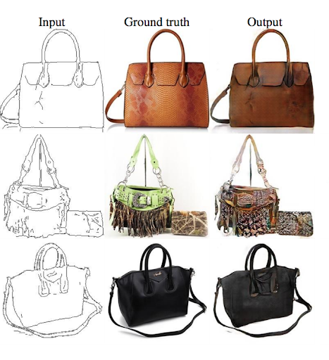
In these cases, the loss is a weighted combination of the usual discriminator-based loss and a pixel-wise loss that penalizes the generator for departing from the source image.
Reference - Isola et al, 2016.

CycleGAN
CycleGANs learn to transform images from one set into images that could plausibly belong to another set. For example, a CycleGAN produced the righthand image below when given the lefthand image as input. It took an image of a horse and turned it into an image of a zebra.
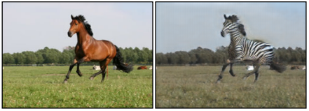
The training data for the CycleGAN is simply two sets of images (in this case, a set of horse images and a set of zebra images). The system requires no labels or pairwise correspondences between images.
Reference - Zhu et al, 2017,

Text-to-Image Synthesis
Text-to-image GANs take text as input and produce images that are plausible and described by the text. For example, the flower image below was produced by feeding a text description to a GAN.
"This flower has petals that are yellow with shades of orange." | 
Note that in this system the GAN can only produce images from a small set of classes.
Reference - Zhang et al, 2016.

Super-resolution
Super-resolution GANs increase the resolution of images, adding detail where necessary to fill in blurry areas. For example, the blurry middle image below is a downsampled version of the original image on the left. Given the blurry image, a GAN produced the sharper image on the right:

Original | Blurred | Restored with GAN
 | 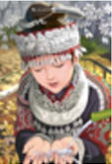 | 
The GAN-generated image looks very similar to the original image, but if you look closely at the headband you'll see that the GAN didn't reproduce the starburst pattern from the original. Instead, it made up its own plausible pattern to replace the pattern erased by the down-sampling.
Reference - Ledig et al, 2017.

Face Inpainting
GANs have been used for the semantic image inpainting task. In the inpainting task, chunks of an image are blacked out, and the system tries to fill in the missing chunks.
Yeh et al, 2017 used a GAN to outperform other techniques for inpainting images of faces:
Input | GAN Output
 | 

Text-to-Speech
Not all GANs produce images. For example, researchers have also used GANs to produce synthesized speech from text input. For more information see Yang et al, 2017.

